Create separate runner file for parallel and sequential

Parallel Test Runner File:

|  |
| --- |
| @CucumberOptions(        //features = "features" features = "NewUI_features" ,glue={"stepdefinitions"},   tags={"@sanity_parallel"}, plugin = {"io.qameta.allure.cucumber5jvm.AllureCucumber5Jvm"} )  public class SanityParallelRunnerTestIT extends AbstractTestNGCucumberTests{ @Override @DataProvider(parallel = true) public Object[][] scenarios() {   return super.scenarios(); } } |

Create a profile for parallel execution and sequential execution in Pom.xml file

|  |
| --- |
| <profiles> <profile> <id>sanityparallel-tests</id> // create a profile ID <build> <pluginManagement> <plugins> <plugin> <groupId>org.apache.maven.plugins</groupId> <artifactId>maven-surefire-plugin</artifactId> <version>2.22.0</version> <configuration> <includes> <include>**/SanityParallelRunnerTestIT.java</include> // include our test runner file </includes> <properties> <property> <name>dataproviderthreadcount</name> //give data provider thread count value <value>3</value> </property> </properties> <argLine>                                     -javaagent:"${settings.localRepository}/org/aspectj/aspectjweaver/${aspectj.version}/aspectjweaver-${aspectj.version}.jar"                                     -Dcucumber.options="--plugin io.qameta.allure.cucumber5jvm.AllureCucumber5Jvm" //include this if we want allure reports </argLine> </configuration> </plugin> </plugins> </pluginManagement> </build> </profile> |

Sequential execution profile in Pom.xml

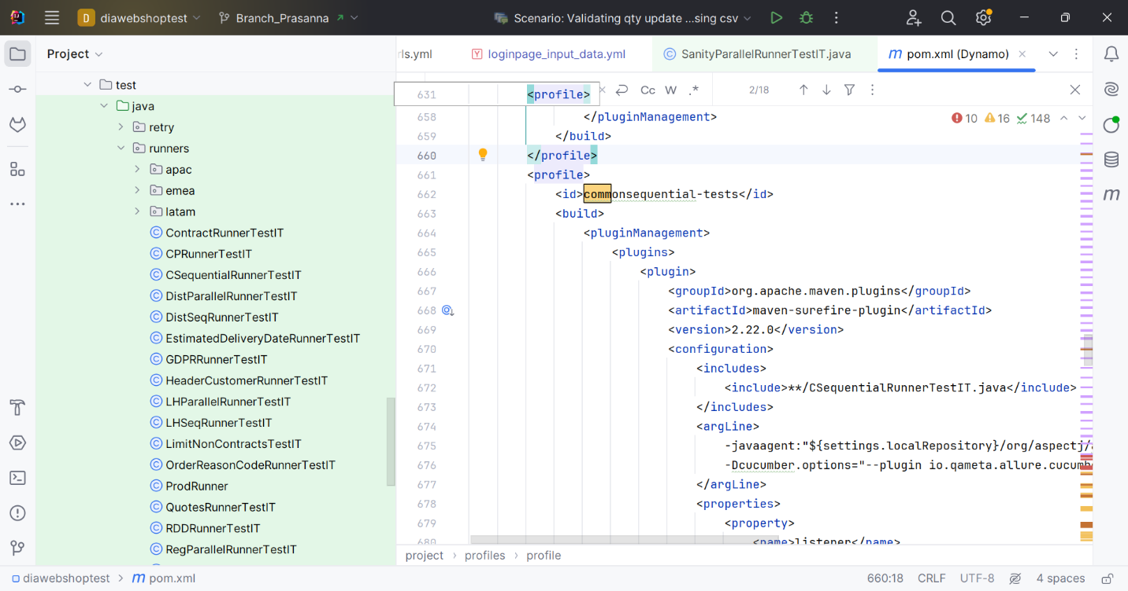

Pass the test runner file name for running the test

|  |
| --- |
| mvn test -Pcommonsequential-tests -Dcucumber.plugin="json:US_commonseqtests.json" |